COS30043 Interface Design and Development
Individual Report: OpenTexila
Show Wai Yan (105293041) | Group G7 | Swinburne University of Technology
Live application: https://opentexila.site | Advanced feature: lecturer attendance analytics dashboard (Chart.js)

1. Contributions
OpenTexila is a Vue 3 and Vite application with Bootstrap 5.3 and a shared design system. My work was on the lecturer side of the frontend, plus some student attendance fixes. I made 20 commits (excluding merges). The table lists what I built; paths are under src/features/.
Area | Files and commits
Lecturer attendance overview (/lecturer/attendance) | attendance/pages/LecturerAttendancePage.vue; SessionList, SessionFilters, SessionSummary, SessionPagination, AvailabilityBadge; use-lecturer-sessions.js; filter-params.js; class-sessions-service.js and a mock service (477c273, 96f23aa, d6b7963, 2455202)
Class session roster page | LecturerClassSessionRecordsPage.vue; RosterTable, RosterStatusFilter, SessionContextHeader, AttendanceStatusBadge; use-class-session-records.js (b8c4e1e)
Class roster page (/lecturer/classes/:classId/students) | enrolments/pages/LecturerClassStudentsPage.vue; ClassRosterTable, ClassContextHeader; use-class-roster.js (758a406)
Lecturer home page | dashboard/pages/LecturerHomePage.vue; HomeSessionCard; use-lecturer-home-sessions.js; home-sessions-window.js (efc09a0, 306cd07, 5023b2c). The visual styling was later reworked by Aung Moe Thu (20c5253); the structure, data loading and states are mine.
Advanced feature: attendance analytics (/lecturer/attendance-analytics) | LecturerAnalyticsPage.vue; components/charts/*; AnalyticsFilters, AtRiskStudentList, UnfinalisedSessionsCard; use-attendance-analytics.js; use-chart-data.js; analytics-query.js (4c19b83, 8d6aaa4)
Student history filter and layout fixes | AttendanceHistoryPage.vue; use-attendance-class-options.js (a2e8796, 1fd3762, 4bc56d9, 1633c91, 16e0d0b, 39802f8); table-responsive fix in assets/styles/components.css (1bc06cf)
All pages follow the shared design patterns of the project: the ot-card, ot-notice and ot-table classes, a shared RequestState component for loading, empty and error states, and a Bootstrap grid that stacks on phones. Each feature has Vitest tests for its composables and pure functions (for example tests/chart-data.test.js and tests/attendance-analytics-composable.test.js).

2. Advanced feature: lecturer attendance analytics with Chart.js

2.1 What it is and why it was included
The analytics page gives a lecturer a view that no list page can: how attendance changes over time and who needs attention. It shows three summary tiles (submitted sessions, attendance rate, number of students at risk), an attendance trend line chart, a status breakdown doughnut chart, a class comparison bar chart, and an at-risk student table with an adjustable threshold. Filters for class, date range and threshold are kept in the URL, so a view can be bookmarked or shared. A further card lists ended sessions that are still waiting for the attendance record to be submitted (Figures 1 and 2).
Rationale. The roster pages show one session at a time, so a lecturer with 25 to 30 students per class must open many pages to spot a pattern. Charts show trend, proportion and comparison at a glance, and the at-risk table turns the pattern into a list of names. Chart.js and the vue-chartjs wrapper are not covered in the unit, and the project otherwise avoids extra UI libraries. The team agreed to make an exception for charts, because the alternative of hand-drawn SVG would have meant writing axes, tooltips, legends and responsiveness myself.
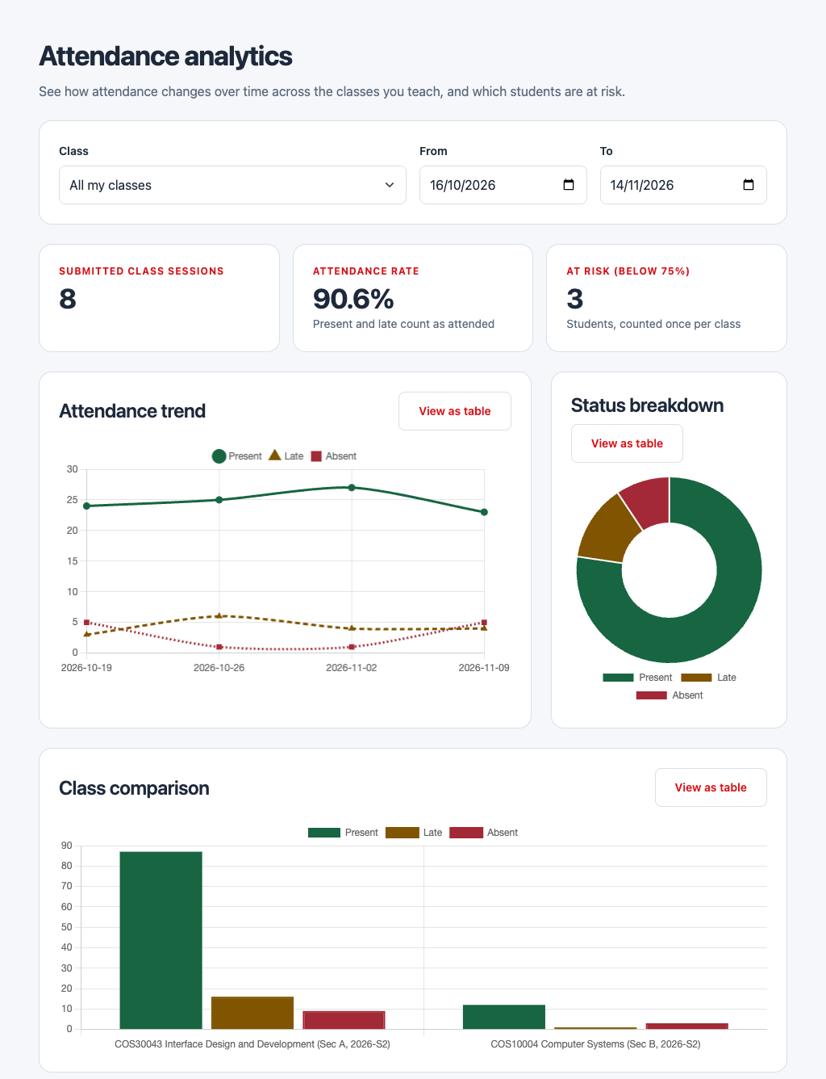 | 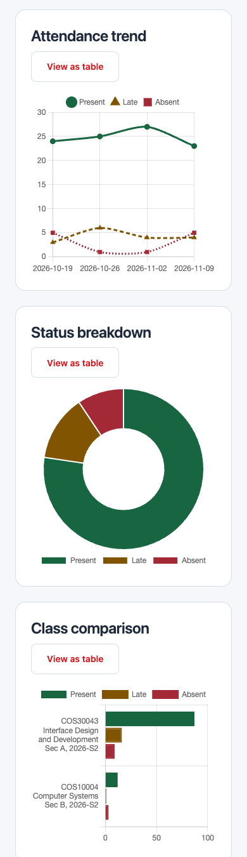
Figure 1. Analytics page on desktop (left, charts section) and on a 390 px phone (right, charts stack and the class comparison switches to horizontal bars).

2.2 Techniques used
Tree-shaken registration and lazy loading. Chart.js 4 is modular, so chart-setup.js registers only the elements used (line, bar, arc, two scales, legend, tooltip) instead of importing everything. The page loads each chart with defineAsyncComponent, so Chart.js is split into its own chunk and is only downloaded when a lecturer opens the page, with a skeleton shown meanwhile.
// components/charts/chart-setup.js
Chart.register(ArcElement, BarElement, CategoryScale, Legend,
LineElement, LinearScale, PointElement, Tooltip);
// pages/LecturerAnalyticsPage.vue
const lazyChart = (loader) =>
defineAsyncComponent({ loader, loadingComponent: ChartSkeleton, delay: 0 });
const ClassComparisonChart = lazyChart(
() => import('../components/charts/ClassComparisonChart.vue'));
Reactive charts through vue-chartjs. Each chart component (AttendanceTrendChart, StatusBreakdownChart, ClassComparisonChart) is small. It passes a computed chart configuration to a vue-chartjs component, which creates the Chart.js instance on mount, updates it when the data prop changes and destroys it on unmount, so I did not write that lifecycle by hand. Because Chart.js draws on a canvas and cannot read CSS variables, onMounted reads the design tokens --ot-success, --ot-warning and --ot-danger once with getComputedStyle (read-palette.js), so the charts keep the same colours as the status badges.
const palette = ref(undefined);
onMounted(() => { palette.value = readPalette(); });
const chart = computed(() =>
buildClassComparisonChart(props.byClass, { palette: palette.value }));
// <Bar :data="chart.data" :options="chart.options" />
Pure data mapping in use-chart-data.js. Functions such as buildTrendChart and buildStatusBreakdownChart take API data and return one object: the Chart.js type, data and options, an aria label, a text summary, and tableColumns and tableRows for the table view. The file imports neither Vue nor Chart.js, so it is unit tested directly. The doughnut shares (count divided by total, formatted by formatRate) and the class labels are derived here. The attendance rate and the at-risk list themselves are calculated by the backend and only displayed by the frontend.
Composable for state and requests. use-attendance-analytics.js holds the filters (reactive), the loaded data, loading and error refs and an isEmpty computed value. A change to a filter is validated, written to the URL with router.replace through the onFiltersChange callback, and then the request is debounced by 300 ms. Each new request aborts the previous one with AbortController and ignores late replies using a request counter, so quickly changing the dates cannot show stale charts. A 422 response is mapped back to the field that caused it. The page also uses watch for a 403 redirect and for loading room names of waiting sessions, onMounted for the first load, and onBeforeUnmount to call dispose().
controller?.abort(); controller = new AbortController();
const id = ++requestId;
const payload = await service.getAttendanceAnalytics(requested, { signal });
if (id !== requestId) return; // a newer request has replaced this one
Accessible alternative for every chart. A canvas is invisible to screen readers, so BaseChart.vue wraps each chart in a card with role="img" and an aria-label, a visually hidden text summary, and a "View as table" toggle (aria-pressed, aria-controls) that swaps the canvas for a real table with a caption and row headers from the same tableRows. Colour is not the only cue: the three series also differ by point shape and line dash pattern (STATUSES in use-chart-data.js), and the colours were chosen for contrast on a white card. BaseChart also owns the loading, error with retry and empty states through RequestState, so the three charts behave the same way.
state = props.error ? 'error' : props.loading ? 'loading'
: props.chart.empty ? 'empty' : 'success' // computed in BaseChart
<button :aria-pressed="showTable" @click="showTable = !showTable">
{{ showTable ? 'View as chart' : 'View as table' }}</button>
Responsive layout. The options set responsive: true and maintainAspectRatio: false, and the canvas sits in a fixed-height frame (18 rem) so it resizes with its card. The Bootstrap grid places the trend and doughnut side by side from the xl breakpoint (col-xl-8 and col-xl-4) and stacks them below that. The at-risk table sits in a focusable, scrollable table-responsive region.

2.3 Unfinalised sessions
While testing against the real backend I found that only finalised sessions count in the analytics, and that nothing finalises a session automatically. A lecturer would therefore see missing data without knowing why. In 8d6aaa4 I added UnfinalisedSessionsCard, which lists ended sessions that still have pending records, warns that pending students become absent, and calls the finalise endpoint and then reloads. I also changed the wording from "ended" to "finalised" across the tiles and empty states, and an analytics result containing only unfinalised sessions is no longer shown as empty. The card text and button label were later refined by Aung Moe Thu (3f02120, "submit the attendance record").

3. Other key techniques
- Composables and layering. Each page follows the same pattern: a page component, a composable that owns requests, and a service with a mock implementation used while the backend contract was still open. Components only receive props and emit events. The list, roster and home composables all use the same AbortController and request-id guard shown above.
- Filters and client-side paging. The attendance overview reads filters through filter-params.js, which converts dates and rejects invalid ranges with a RangeError that the page shows as a field message. Because the API could not filter sessions by status, use-lecturer-sessions.js fetches all matching sessions, filters them by status in the browser and pages the result.
- States and accessibility. Every data page has loading, empty, error-with-retry and not-found states (for example in use-class-session-records.js), a status badge that pairs colour with text, labelled inputs, and aria-live regions for status messages.
- Dates. The lecturer home page computes a seven-day window in Malaysia time (home-sessions-window.js) and groups sessions into Today and Upcoming.
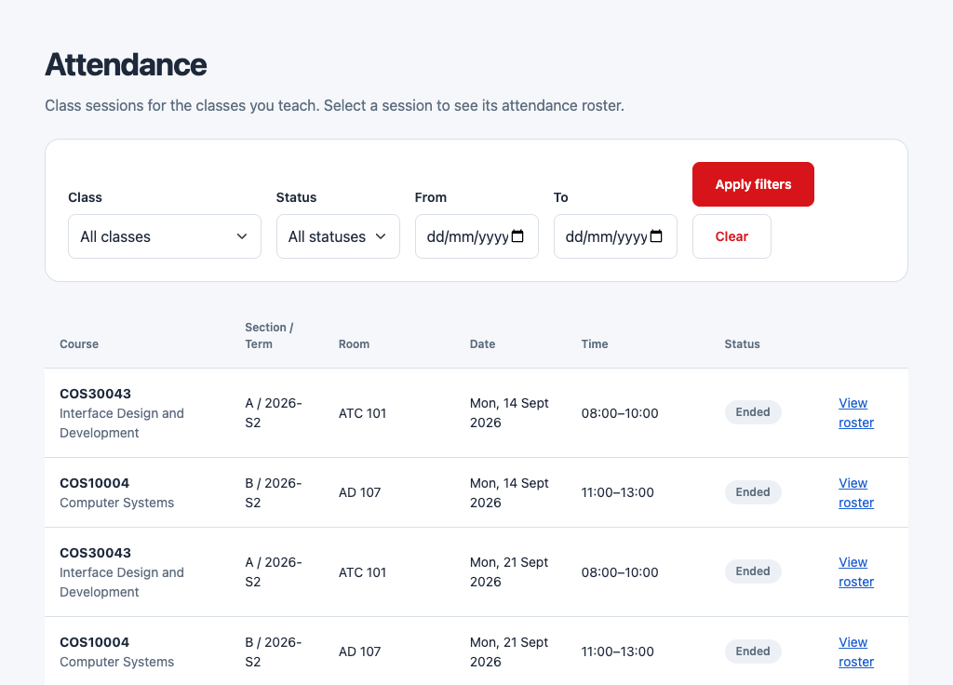 | 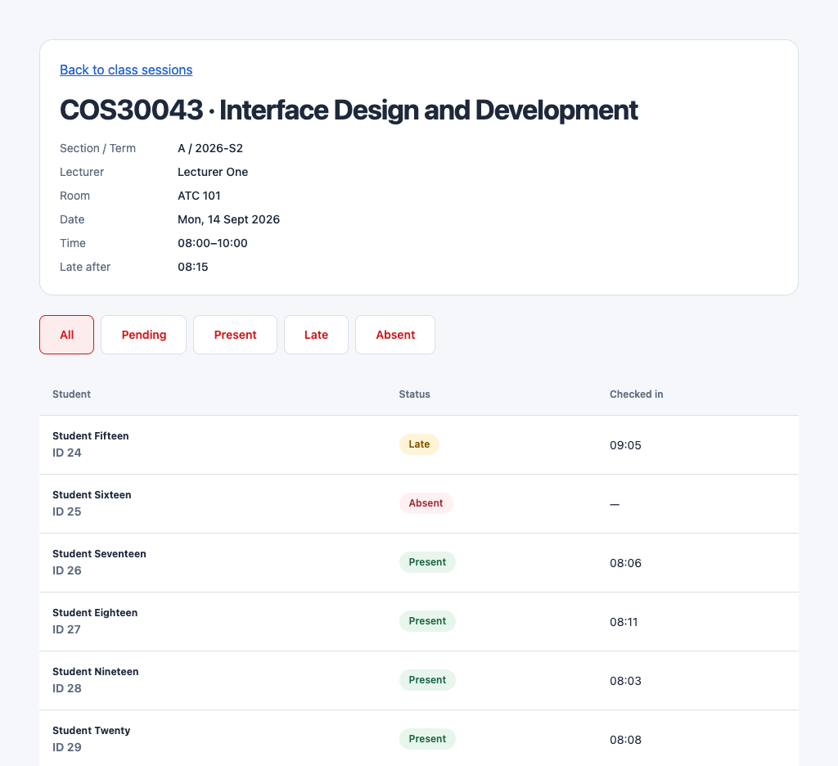
Figure 2. Lecturer attendance overview with filters (left) and the class session roster with status filter and paging (right).

4. Challenges and resolutions
- Class filter did not update (e69abfe). The dropdown on the attendance overview stayed empty after sessions loaded. The known-classes Map was a plain Map, so Vue did not track it. I wrapped it with reactive(new Map()) and added a regression test.
- Incomplete class filter in student history (a2e8796, 1fd3762). Options were built from the records on the current page, so classes that were not on that page, or former classes, could not be chosen. I added use-attendance-class-options.js, which loads every page of the class list and removes duplicates by id. When the lookup fails the select stays usable, shows the active class as a fallback, and offers Retry without blocking the records table.
- Filter bar alignment (4bc56d9, 1633c91, 16e0d0b, 39802f8). The lookup message pushed the class select out of line with the other controls. I moved the message and the Reset button to a separate footer row, aligned the controls with the grid, and made Reset full width on phones.
- Stray scrollbar in responsive tables (1bc06cf). Setting overflow-x: auto makes overflow-y compute to auto as well, so a one pixel rounding difference showed a vertical scrollbar inside .table-responsive. A single rule, overflow-y: hidden, fixed it for every table.
- Home card wrapping (306cd07, 5023b2c). Session text and the action button wrapped awkwardly in narrow cards. I removed the nowrap class from the quick-link cards and adjusted HomeSessionCard so text can shrink while the button keeps its size.
- Missing analytics data explained to the user (8d6aaa4). See Section 2.3: the unfinalised card and consistent "finalised" wording.
- Chart readability on small screens. Our group testing found the Class Comparison chart compressed and hard to read at about 370 px, because long class names share a narrow horizontal axis. The deployed build now draws the bars horizontally on narrow screens (Figure 1, right), and the table view is always available as a fallback.

5. Reflection
Building the analytics page showed me that a chart is only useful in an interface if it is accessible, has all of its states and fits small screens, which took more effort than drawing it. Separating pure mapping functions from components made the chart logic easy to test, and a shared BaseChart kept the three charts consistent. If I had more time I would test the chart text with a screen reader, add a printable or exportable view, and move the class comparison to a layout that scales to many classes. I also learned to read backend behaviour early, because the finalisation rule changed what the interface had to explain.

